***Requirements Management – II***

***Lecture # 19***

***Recap of Last Lecture***

* We talked about requirements management and why is it necessary to manage requirements changes rather than disallow changes in requirements
* We’ll continue our discussion on requirements management today

***Requirements Identification***

* It is essential for requirements management that every requirement should have a unique identification
* The most common approach is requirements numbering based on chapter/section in the requirements document
* Problems with this are:
  + Numbers cannot be unambiguously assigned until the document is complete
  + Assigning chapter/section numbers is an implicit classification of the requirement. This can mislead readers of the document into thinking that the most important relationships are with the requirements in the same section

***Requirements Identification Techniques***

* *Dynamic renumbering*
* *Database record identification*
* *Symbolic identification*

***Dynamic Renumbering***

* Some word processing systems allow for automatic renumbering of paragraphs and the inclusion of cross-references. As you re-organize your document and add new requirements, the system keeps track of the cross-reference and automatically renumbers your requirement depending on its chapter, section and position within the section

***Database Record Identification***

* When a requirement is identified it is entered in a requirements database and a database record identifier is assigned. This database identifier is used in all subsequent references to the requirement

***Symbolic Identification***

* Requirements can be identified by giving them a symbolic name which is associated with the requirement itself. For example, EFF-1, EFF-2, EFF-3 may be used for requirements which relate to system efficiency

***Storing Requirements***

* Requirements have to be stored in such a way that they can be accessed easily and related to other system requirements

***Requirements Storage Techniques***

* In one or more word processor files
* In a specially designed requirements database

***Word Processor Documents: Advantages***

* Requirements are all stored in the same place
* Requirements may be accessed by anyone with the right word processor
* It is easy to produce the final requirements document

***Word Processor Documents: Disadvantages***

* Requirements dependencies must be externally maintained
* Search facilities are limited
* Not possible to link requirements with proposed requirements changes
* Not possible to have version control on individual requirements
* No automated navigation from one requirement to another

***Requirements Database***

* Each requirement is represented as one or more database entities
* Database query language is used to access requirements

***Requirements Database: Advantages***

* Good query and navigation facilities
* Support for change and version management

***Requirements Database: Disadvantages***

* Readers may not have the software/skills to access the requirements database
* The link between the database and the requirements document must be maintained

***Requirements Database Choice Factors***

* *The statement of requirements*
* *The number of requirements*
* *Teamwork, team distribution and computer support*
* *CASE tool use*
* *Existing database usage*

***The statement of requirements***

* + If there is a need to store more than just simple text, a database with multimedia capabilities may have to be used

***The number of requirements***

* + Larger systems usually need a database which is designed to manage a very large volume of data running on a specialized database server

***Teamwork, team distribution and computer support***

* + If the requirements are developed by a distributed team of people, perhaps from different organizations, you need a database which provides for remote, multi-site access

***CASE tool use***

* + The database should be the same as or compatible with CASE tool databases. However, this can be a problem with some CASE tools which use their own proprietary database

***Existing database usage***

* + If a database for software engineering support is already in use, this should be used for requirements management

***Change Management***

* Change management is concerned with the procedures, processes and standards which are used to manage changes to system requirements
* Without formal change management, it is impossible to ensure that proposed changes support business goals

***Change Management Policies***

* The change request process and the information required to process each change request
* The process used to analyze the impact and costs of change and the associated traceability information
* The membership of the body which formally considers change requests
* The software support (if any) for the change control process

***Change Management Stages***

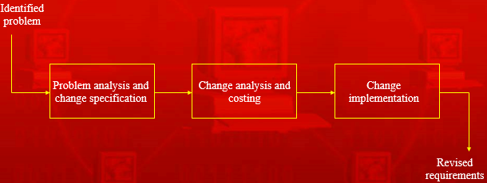

***Problem Analysis and Change Specification***

* Some requirements problem is identified
* This could come from an analysis of the requirements, new customer needs, or operational problems with the system. The requirements are analyzed using problem information and requirements changes are proposed

***Change Analysis and Costing***

* This checks how many requirements (and, if necessary, system components) are affected by the change and roughly how much it would cost, in both time and money, to make the change

***Change Implementation***

* A set of amendments to the requirements document or a new document version is produced. This should, of course, be validated using whatever normal quality checking procedures are used

***Change Analysis and Costing Process***

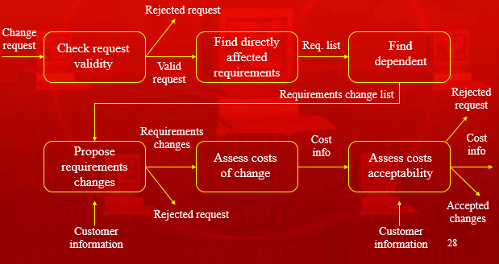

***Change Analysis Activities***

* The change request is checked for validity. Customers can misunderstand requirements and suggest unnecessary changes
* The requirements which are directly affected by the change are discovered
* Traceability information is used to find dependent requirements affected by the change
* The actual changes which must be made to the requirements are proposed
* The costs of making the changes are estimated.
* Negotiations with customers are held to check if the costs of the proposed changes are acceptable

***Change Request Rejection Reasons***

* If the change request is invalid. This normally arises if a customer has misunderstood something about the requirements and proposed a change which isn’t necessary
* If the change request results in consequential changes which are unacceptable to the user.
* If the cost of implementing the change is too high or takes too long

***Change Processing***

* Proposed changes are usually recorded on a change request form which is then passed to all of the people involved in the analysis of the change. It may include
  + Fields to document the change analysis
  + Data fields
  + Responsibility fields
  + Status field
  + Comments field

***Tool Support for Change Management***

* May be provided through requirements management tools or through configuration management tools

***Tools Features***

* Electronic change request forms which are filled in by different participants in the process
* A database to store and manage these forms
* A change model which may be instantiated so that people responsible for one stage of the process know who is responsible for the next process activity
* Electronic transfer of forms between people with different responsibilities and electronic mail notification when activities have been completed
* In some cases, direct links to a requirements database

***Summary***

* Requirements management requires that each requirement should be uniquely identified
* If a large number of requirements have to be managed, the requirements should be stored in a database and links between related requirements should be maintained
* Change management policies define the processes used for change management and necessary information
* Automated support for change management should come through specialized requirements management tools or by configuring existing tools to support change management